REFORMING PILLAR II OF THE PCRI TO REBOOST COMPETITIVENESS: PROPOSALS FROM FRANCE UNIVERSITES

In the recommendations it made in February 2024 concerning FP10 (Microsoft Word - Proposition FP 10 V16 FR),, France Universités proposed in particular a strengthening of fundamental research including within pillar II. It recommended in particular that "the next framework programme respects a principle of balance by increasing the number of call subjects focused on the creation of new knowledge and low TRLs for research resourcing".
In line with this reflection, France Universités is now proposing a more in-depth overhaul of pillar II, the subject of many questions or challenges.
Indeed, voices have recently been raised to highlight the urgency of refocusing European investments on strategic sectors, but also the necessary simplification of access to and implementation of programmes aimed at strengthening European innovation and competitiveness.
In her speech to the European Parliament on 18 July 2024, Ursula von der Leyen proposed the creation of a competitiveness fund to support innovation and the Clean Industry Pact, but also to develop strategic technologies in Europe.
In this context, it is becoming necessary to rethink an organisation in which the current Pillar II “clusters” do not allow for the active support of strategic sectors. R&D operators should participate in this simultaneous redefinition of competitiveness and the EU’s positioning. In particular, collaborative research within the next framework programme will have to focus on relaying and strengthening European action in light of this new situation.

France Universités proposes:
- Support displayed for a limited number of strategic sectors, allowing for the design of a close and effective continuity between the financing of the Framework programme and that of the Competitiveness and Research Fund. A “white “sector for emerging themes at risk would be added. The management of the system would be entrusted to DG RTD in close collaboration with DG GROW;
- The registration of the resulting value chains in local ecosystems producing new skills and quality jobs, replicable through transnational networks, within which universities would fully play their leading role;
- The creation of a company with European status, the objective of which will be to temporarily secure companies involved in strategic priority sectors and allowing access to financing (on the model of the European DARPA). Within the framework of the Framework programme and the competitiveness fund, they could also benefit from participation from the EIB guaranteeing development on European soil.
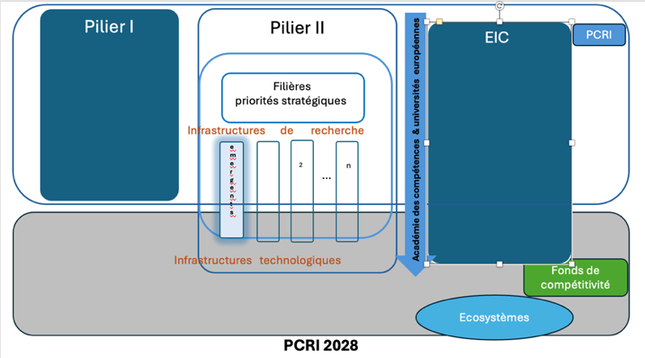

- For a continuum between the collaborative research of the Framework R&I programme and incentive mechanisms within the Competitiveness Fund to strengthen strategic priorities

France Universités considers that the disappearance of Pillar II would constitute a major risk for European research and innovation. Collaborative research is indeed an essential step in moving from research results to a market solution. And it is this continuum that must be strengthened and supported by the junction between the Framework programme and the competitiveness fund on a more limited and visible number of strategic priorities that together integrate societal and industrial issues.

France Universités proposes to strengthen this ambition by adding incentive mechanisms in the Competitiveness Fund for collaborative projects that contribute to the resilience of one of the strategic sectors of Pillar II. In order to benefit from a financial protection loophole of limited duration, the project leaders could request to benefit from dedicated programs as soon as they approach the market (derisking mechanisms potentially linked to a European DARPA, technology transfer, technological infrastructures

2. Achieving critical mass through ecosytems of the European universities
In order to develop, a project needs both industrial support and to spread across a territory and then be able to deploy internationally. Here we find the two meanings of the term "ecosystem" as it exists within the current FP, Horizon Europe: (i) in the sense of a value chain for a given sector of activity (in the European industrial strategy in particular) and (ii) in the sense of the Horizon Europe regulation (article 2(47)) as a set of actors likely to participate in a given territory in technological development and innovation

France Universités recommends relying on higher education institutions, particularly universities, that have developed sustainable innovation ecosystems that can be replicated and standardized in other European territories, to achieve a critical mass to meet the strategic objectives of European R&I. These institutions can accelerate the networking of processes and the dissemination of knowledge and skills between stakeholders in the same territory but also get involved in horizontal strategies for value chains distributed on European soil, in particular via university alliances..

Environmental innovation resulting from academic R&D in particular requires support from public authorities, commitment from stakeholders in the field (employment and training agencies, chambers of commerce, social economy stakeholders, etc.) and the active participation of citizens, who are not limited to the role of end-users, guarantors of social acceptability.

These accompanying measures, aimed at perpetuating within the European market the commercial exploitation of R&I opportunities financed by European funds, would be accompanied by a "de-risking" mechanism for private investors in the form of a guarantee, which would complement the financing of the European Investment Bank.

3. A European company status to strengthen strategic sectors
France Universities welcomes the proposal put forward by Mario Draghi in his report: The Future of European Competitiveness – A Competitiveness Strategy for Europe, to set up a European company status so that innovative start-ups can have a single digital identity in the EU and benefit from harmonized rules across all Member States.

Among the incentive measures, France Universités proposes to consolidate and strengthen this ambition by adding a European company status for companies contributing to the implementation of strategic sectors resulting from university R&D, which would create a transitional protection airlock while they have crossed the valley of death. In exchange, the company would commit to respecting sustainable development objectives and commitment to society and the environment, the provisions of which would be specific to each Member State, based on the model of the mission-driven company status that is currently spreading in Europe..

4. Align skills academies with existing FP instruments and reindustrialization issues
Finally, industrial sectors must use the research>innovation>training continuum via higher education institutions so that it contributes effectively to identified value chains, in particular by creating skills without which new technologies cannot be absorbed or deployed in Europe.

To meet the short, medium and long-term needs of industrial sectors, particularly in the fields of AI, aerospace and clean technologies, France Universités proposes that the skills academies provided for in the Net-Zero Industry Act be equipped with an executive steering capacity between DG R&I, DG Grow, DG Connect, and DG Emp or each of these DGs can be the lead agency depending on the subjects, that they rely on universities in Europe, in particular European universities, that they integrate co-programmed or institutionalized partnerships in small numbers, and that they be funded in line with the challenges.

The absence in Europe of a directory such as the directory of technology, innovation and partnerships designed by the American National Science Foundation to strengthen or encourage the emergence of innovation ecosystems is detrimental to the recognition of a form of organisation that is fully necessary for registering the results of R&I in the territories themselves.

